**Downhole Assay: A game changer for the mining industry**

*Huw Rossiter (Kinetic Logging Services), Vincent Flahaut (Sodern)*

From exploration to mining, quantifying grade and tonnage of the mineral resource requires an enormous effort. Collection of geochemical data is achieved by drilling to sample the ore body. This generates a huge amount of samples, and significant costs and time in preparation and assay. A new technology to the mining industry – The FastGrade™ Pulsed Fast & Thermal Neutron Activation (PFTNA) has been proven to have several advantages over conventional sample based assays including improving safety through reduced site exposure to manual handling, the measurement size of the sample, depth accuracy, cost, and reducing the cycle time for results from up to months to almost immediately once the hole has been logged with the tool.

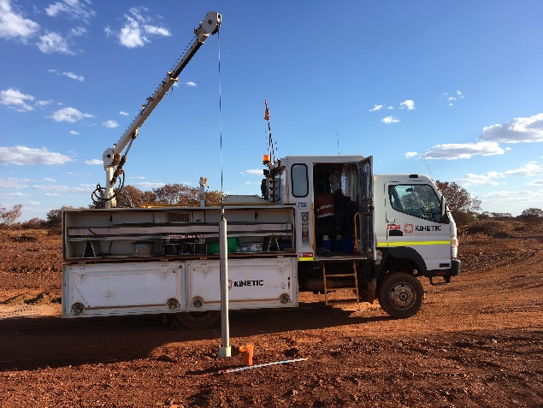

*Figure 1. The FastGrade™ being run in hole*

*Figure 2: FastGradeTM vs RC sample assays*



**Introduction**

Currently 100mm diameter tools are primarily run in iron ore where the tools are being used to log in excess of 150km / year. One major resource company has stated that the tool has saved them in excess of USD 10 million in a year. The main elements measured for iron ore are shown in figure 2. The chart shows typical results compared against 3m sampled reverse circulation (RC) holes assay data (column 2) across the range of values (columns 3 and 4)

Minor elements can also be measured depending on ore grade – these include some of the base metals such as Cu or Ni, and also elements such as potassium and chlorine. The FastGrade™ is currently being scheduled to be demonstrated in a selection of base metal deposits that will show how the tool can provide value across a wide resource base.

A key component of the tool is the pulse neutron generator. In contrast to a chemical source used in conventional neutron and density logging tools, without power the tool does not produce radiation. This removes the risks associated with exposure at surface and mining issues in the unlikely event that the tool is lost in hole.

**Measurement Theory**

The FastGrade™ technology uses an electronic pulse neutron generator source to emit neutrons that penetrate the surrounding rock and lose their energy when colliding with nuclei. As they penetrate, they initiate interactions according to the formation, as fast inelastic collisions or neutron capture that result, nearly instantaneously, in the emission of gamma photons. Each element produces photons with a set of characteristic energies, which is the key to identifying and quantifying them. A high resolution, scintillating material coupled with a photomultiplier converts the photons into electrical pulses and a fast processing, specialized circuit digitizer sorts and counts them to build their spectrum.

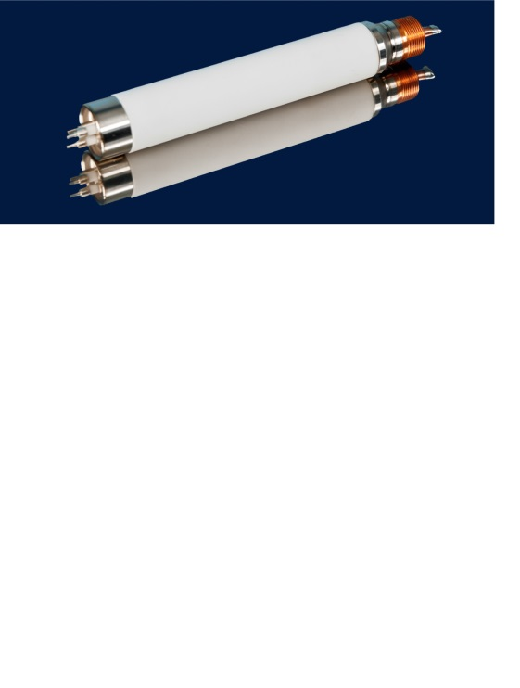

*Figure 3: SODERN sealed Neutron Tube*

At this point a computer can extract element footprints out of the spectrum to determine the chemistry of the formation.

*Figure 5: Multi elemental log*

*Figure 4: FastGradeTM Spectrum & individual elemental response*

**Measurement accuracy compared to conventional sampling**

Using the FastGrade™ technology is fundamentally different to collecting a physical sample and sending it to the laboratory, and whilst there are limitations around the ability to accurately measure elements present in very small quantities the method of gathering data through this technique has many advantages when compared to physical samples gathered through the drilling process. These include:

* Accurate depth of sampling.

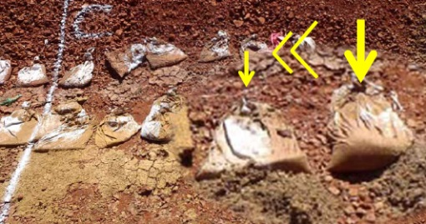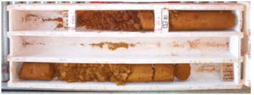

*Figure 6. Damaged sample bags*

*Figure 7. Missing core*

* No lost zones of data.
* No sample contamination.
* No damage to samples on surface.
* Almost immediate return of results.
* A large sample volume provided through the 30 – 50cm radius of investigation.
* The preservation of the natural profile variability when heterogeneous deposits are explored.

In figure 8, the accuracy of data from blasthole, RC and diamond drilling is shown versus the Fastgrade™ technology. It highlights the inherent accuracy deficiencies associated with the different methods of gathering physical samples. Whilst it can be seen that samples derived from diamond core drilling are superior to both RC and blasthole samples the method is still liable to core loss and the cost of diamond core drilling limits the amount of sampling that can be done within budget constraints. Therefore Fastgrade™ has the potential to replace all of these methods with a more cost effective, quicker and accurate way of gathering assay information in the correct geological environment.

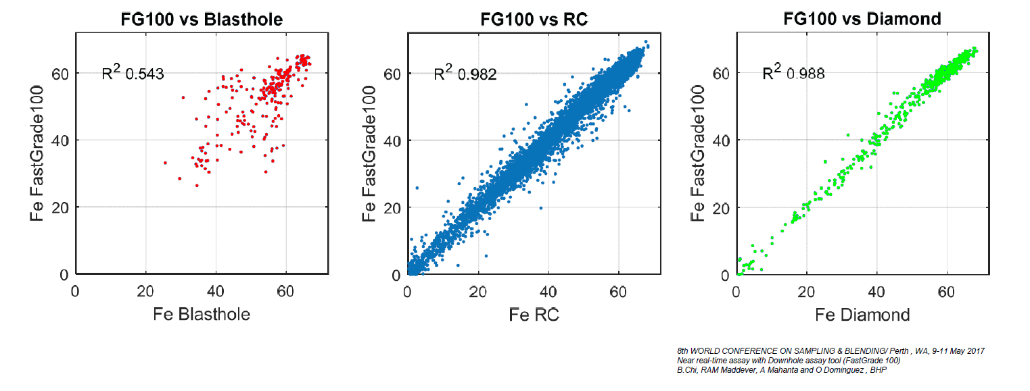

*Figure 8. A comparison of FastGrade™ Fe% vs assay data from Blasthole, RC drilling and diamond drilling samples* (Chi *et al.*, 2017)*.*

RC drilling is often used in preference to diamond drilling due to the cost differential between the two techniques. Diamond drilled twinned holes drilled within 10m of an RC hole are commonly used to verify mineralisation identified by RC samples. The data is used to assess whether there is any sampling bias in the RC sampling technique (Chi *et al.*, 2017).

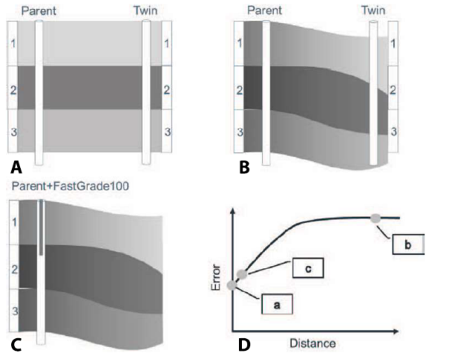

*Figure 9. Flaw in twin hole pairing technique: (A) is the assumed case; (B) is a more realistic RC – diamond drilling case; (C) is the twinning case with a FastGrade™ tool under the same realistic conditions as (B); (D) demonstrates these concepts on a schematic semi-variogram type plot where we can see that as the distance between pairs increase, the error increase due to change in geometry and grade variability* (Chi *et al.*, 2017)

Figure 9, shows this technique can be flawed as the comparison of the data assumes the geometry of the geology is flat lying with consistent thickness, and that the inherent errors associated with both techniques are comparable.

In deposits where it is suitable, the use of the Fastgrade™ technology as an alternative to RC sampling would improve the accuracy of the data from the parent hole and remove the requirement for expensive twin hole drilling campaigns.

Figure 10 shows how improving orebody knowledge through the use of Fastgrade™ to reduce the errors associated with sampling, can have major impacts on mining operations. The example which is based in an iron ore environment shows that reducing error associated with the grade assessment from 3% to 1% can have a significant impact on ore recovery.

The decrease in error leads to a reduction in stripping ratio and loss of ore, increasing the amount of ore that can be sold. This has the added benefit of reducing the environmental impact during operations through the reduction of waste at the minesite.

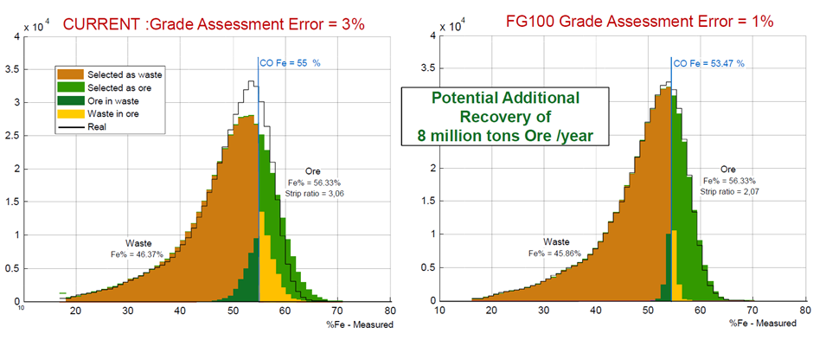

*Figure 10. Showing how decreasing grade assessment error can lead to potential increased ore recovery*

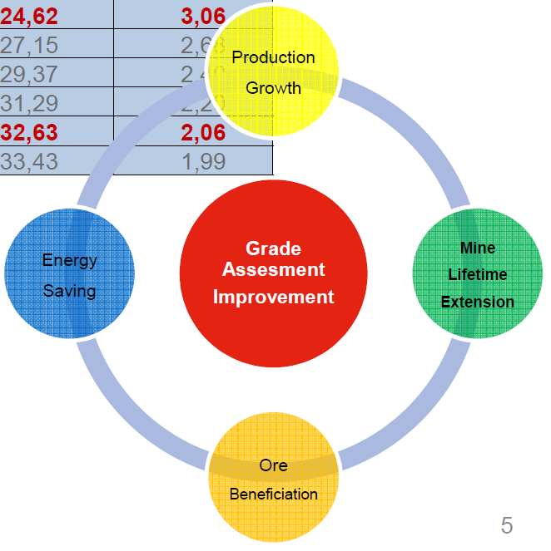Improving grade assessment can have a major impact on the economics and NPV of mining projects. The Fastgrade™ technology has been shown when used in projects where it is suitable to improve safety, reduce the costs and time associated with sampling, and reduce the error compared to currently sampling techniques.

For more information please contact; Huw Rossiter, [huw.rossiter@kinetic.group](mailto:huw.rossiter@kinetic.group) +61 8 9452 6800 013 or Vincent Flahaut, [vincent.flahaut@sodern.fr](mailto:vincent.flahaut@sodern.fr) +33 1 45 95 70 38

|  |  |
| --- | --- |
|  |  |

References:

Chi, B. *et al.* (2017) ‘Near real-time assay with downhole assay tool (FastGradeTM 100)’, in *Eighth World Conference on Sampling and Blending*. Perth: AUSIMM, pp. 137–144.