**Horizon Oil - focused on the future**

The sharp and sustained fall in prices experienced since 2014 has been the defining feature of the oil and gas industry in recent times. Globally, many projects have been deferred or cancelled, the workforce has been in decline and there have been substantial reductions in exploration expenditure around the world. While Horizon Oil is not immune to the challenges facing the industry generally, the Australian based, ASX-listed upstream oil and gas company continues to see attractive opportunities in Papua New Guinea and is pushing ahead with plans to commercialise its gas-condensate resources in PNG’s remote, but highly prospective, Western Province.

It is noteworthy that despite the difficult market conditions, Papua New Guinea continues to attract strong competitive interest from major investors. This interest has been demonstrated by the entry of Total S.A. into Elk/Antelope and more recently, by ExxonMobil's US$2.5 billion purchase of InterOil Corporation. Furthermore, substantial expenditure on exploration and appraisal drilling continues to be incurred by large companies (including Oil Search and Santos) in close proximity to Horizon Oil's Licence areas. This investment activity highlights the stability and attractiveness of PNG as an oil and gas investment destination. It also underlines the value of Horizon Oil's material PNG asset portfolio; a commanding acreage position in the northern forelands of Western Province which includes a Petroleum Development Licence over the Stanley Field (PDL 10), and Petroleum Retention Licences over the Elevala and Ketu Fields (PRL 21), the Puk Puk and Douglas Fields (PRL 40) and the Ubuntu Field (PRL 28).

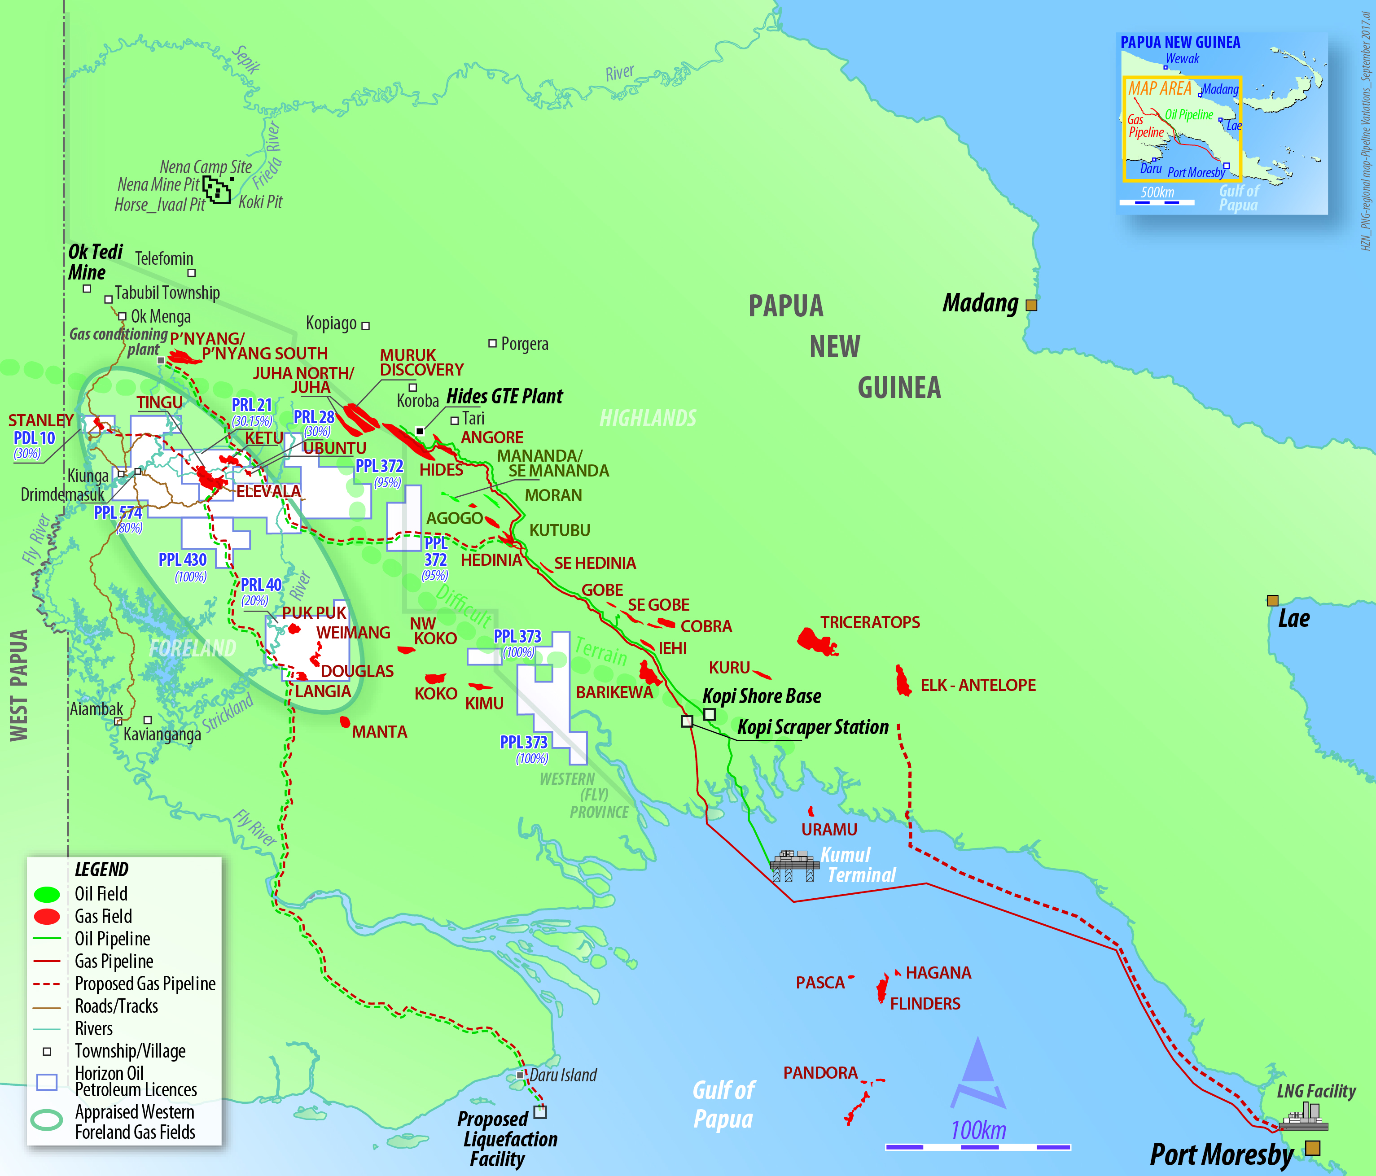

***Gas commercialisation pathways emerging***

Horizon Oil's primary focus is to develop its Western Province resources and work completed to date has identified a number of promising gas commercialisation pathways. PRL 21, which contains the Elevala and Ketu fields, is of particular importance in this context. The Elevala and Ketu gas-condensate fields contain a combined independently certified gross contingent resource (2C) of 1.4 trillion cubic feet of gas and 56 million barrels of condensate, forming the cornerstone volume needed for Horizon Oil's gas commercialisation efforts. These gas-condensate fields were originally discovered in the early 1990s and are located some 60 km east of the Western Province port town of Kiunga. A comprehensive appraisal program, consisting of 3 appraisal wells and 205 km of 2D seismic, was completed between 2011 and 2013 with the results of that appraisal program and subsequent analysis confirming the commerciality of the Elevala and Ketu fields.

The high ratio of condensate to gas found in both the Elevala and Ketu fields initially supported a two phase development plan aimed initially at gas recycling and condensate recovery in the first phase, with gas commercialisation options to be evaluated and matured in a subsequent second phase of the development. A Petroleum Development Licence application was submitted to the PNG Government on that basis in March 2014, targeting initial condensate production of 10,000 to 12,000 barrels per day. Pleasingly, there has been significant progress made with the regulatory approval process, including receipt of formal approval by the PNG Conservation and Environment Protection Authority of the Elevala development Environmental Impact Statement.

In response to the recent commodity price market, when oil prices were sitting below US$50/barrel, the attention of Horizon Oil and its PRL 21 joint venture partners turned to combining both phases by accelerating the gas commercialisation phase of the overall development plan. Horizon Oil's proposed Western LNG project seeks to aggregate these gas fields to develop 2.0 to 2.5 trillion cubic feet of gas and 60 to 70 million barrels of condensate. The aim is to export the gas and condensate via pipeline and an offshore LNG facility which will have a capacity of around 1.5 million tonnes per annum.

Crucially, the resources in Western LNG are held by only 6 participants, with almost 70% concentrated in the hands of Horizon Oil and the Spanish major Repsol. This consolidation of ownership is important as it will make the process of development planning and aggregation simpler than with a widely dispersed ownership group.

The LNG market is becoming rapidly aware of the potential of smaller LNG developments, with strong demand growth for LNG in emerging South East Asian economies, particularly in relation to dispersed power generation, and this is largely being driven by new entrants who want greater flexibility of supply. PNG is somewhere of a sweet spot from which to meet those needs.

Western LNG is targeting start up in the early 2020s when it is anticipated that the South East Asian markets will be undersupplied with LNG. While focusing on export markets a key component of the development criteria is making sure that the development plan maximises the potential for domestic PNG market access for gas and LPG. The design concept provides multiple gas offtake points for local industrial consumers and power generation.

Preliminary economics are attractive and Western LNG, if successful, will be expected to generate around US$1 billion a year for 20 years or more. The project is in pre-Front End Engineering and Design now, Horizon Oil anticipates proceeding into Front End Engineering and Design in 2018, with a Final Investment Decision scheduled for 2019.

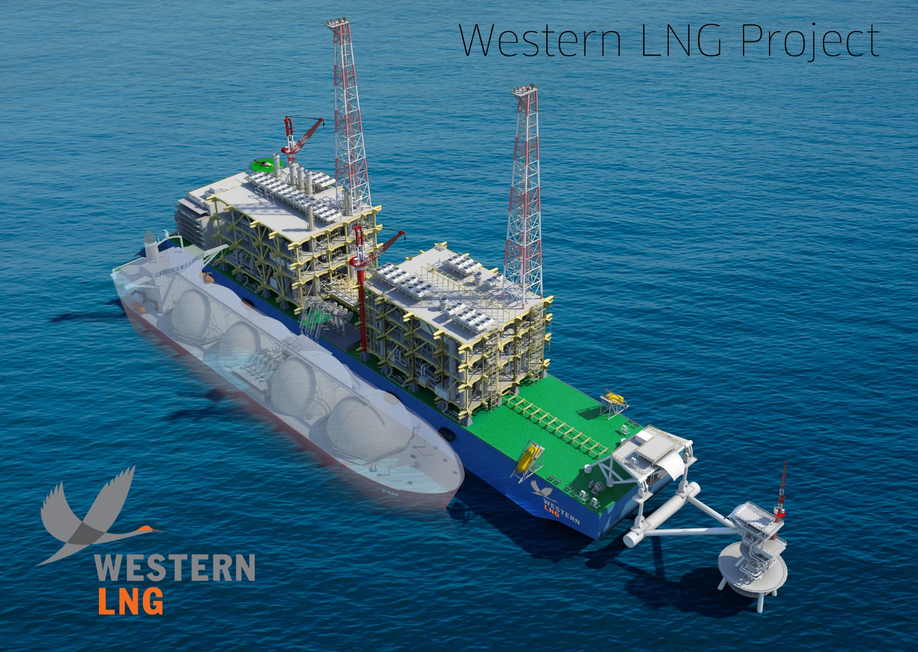

Although focusing on export opportunities, Horizon Oil is a strong supporter of proposals aimed at developing PNG’s resources for domestic consumption and the Company is actively pursuing domestic market opportunities. PNG’s mineral resource industry provides substantial opportunities to substitute clean natural gas for diesel or heavy fuel oil-fired power, adding value not only to mining operations but also to power intensive mineral processing and refining within PNG. Horizon Oil's gas resources, along with the significant upside potential provided by nearby exploration prospects continue to represent a significant commercial opportunity for PNG and the Western Province to establish and develop infrastructure, industrial activity, employment and export revenue based on a secure and long-term gas and fuel supply resource.

***Stakeholder engagement - an ongoing priority***

While focused on the technical task of planning and designing a major gas project, Horizon Oil remains cognisant of the broader social context in which it operates in PNG. Community expectations do not change with a rise or fall in the price of oil or gas and like many resource developers, Horizon Oil expends considerable effort on stakeholder engagement. Many of Horizon Oil's project area communities are located in remote, difficult to reach areas. A core tenet of Horizon Oil's stakeholder engagement activity is the maintenance of 'face to face' contact, essential for building positive relationships. This work is primarily led by the Community Affairs team who make regular visits to project area villages, often staying overnight, to conduct formal and informal information sessions. These village visits are fundamental and provide community members with an important opportunity to ask questions, share their views or offer insights into Horizon Oil's activities.

Although the current commodity price environment has caused Horizon Oil, like all petroleum companies, to cut costs, this does not extend to our commitment to community support and in this regard the Company has maintained our partnerships with Australian Doctors International and Mercy Works. ADI is a not-for-profit, non-government development aid organisation which has been focused on strengthening primary health care services in rural and remote communities in PNG since 2002, and Mercy Works provide maternal health focused training services to regional health centres and rural aid posts, training programs for women and low cost child care for working mums along with workshops in rural communities aimed at minimising violence in families and communities. The partnerships see Horizon Oil allocate A$100,000 (PGK200,000) annually to support the deployment of voluntary medical practitioners in the Western Province of PNG. Two ADI doctors have been deployed since 2016 and the partnership is on track to deliver a broad program of clinical consultation with structured and unstructured in-service training to health workers in remote Western Province communities.

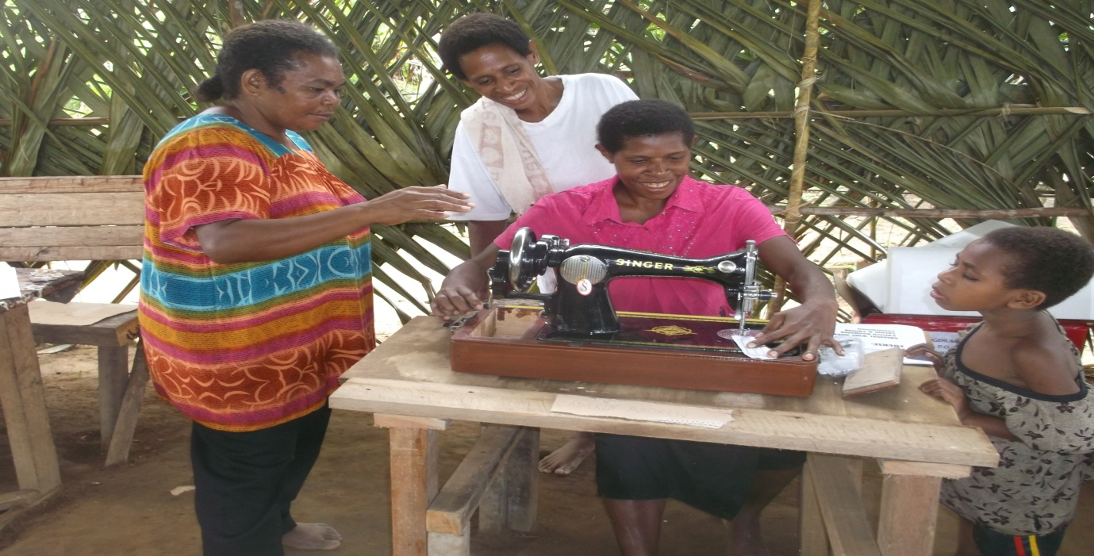

There is no doubt that the last few years have been challenging ones for the oil and gas industry. Nevertheless, Horizon Oil continues to see robust opportunities in PNG and remains firmly focused on pursuing those opportunities with the intention of bringing its Western Province resources to production.