**Accessibility, security key data management concerns, survey reveals**

by VIRGINIA HEFFERNAN

The inability to find and access data via a single integrated search tool emerged as the biggest challenge for respondents to [Geosoft’s 2017 Geoscience Information Management Survey.](http://www.geosoft.com/geoscience-data-management-survey-2017)

Consistent with Geosoft’s past four surveys on the subject, the vast majority of respondents (83%) consider data management a critical or “top five” issue for their organization, compared with only 3% who consider it unimportant. But they continue to encounter challenges and barriers to success, especially how to find the data they need and keep that information secure.

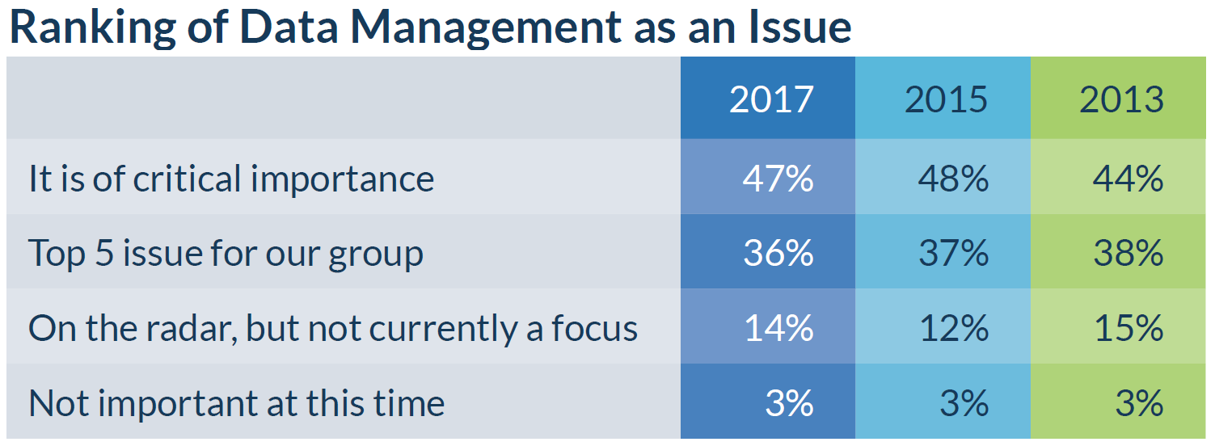

This year, Geosoft received 1400 responses to the survey from 1000 organizations in 115 countries. Half of the respondents are from the mineral resources industry, while the remainder are from the government, energy, near surface or education sectors. Geoscientists – including geophysicists, geologists, GIS specialists and geochemists - represent 70% of the respondents. The rest identify as executives, managers, owners, data and IT administrators, teachers, researchers or students.

The top three most important data types for the participants were geological, geophysical and drill hole or well data. The majority manage this data either on their own or within a folder or file structure on a centralized server, rather than use a commercial solution. More than 60% are confident in the way their organizations handle the quantity and quality of data.

“It’s promising that most respondents have confidence in their organization’s current data handling, but being able to find and access all their data from a single search tool remains a challenge,” says Ken Howieson, Geosoft’s Vice President of Services.

In 2017 the survey was expanded with new questions to reflect the rising importance of the cloud and to gain a better understanding of the challenges organizations face when implementing a data management solution.

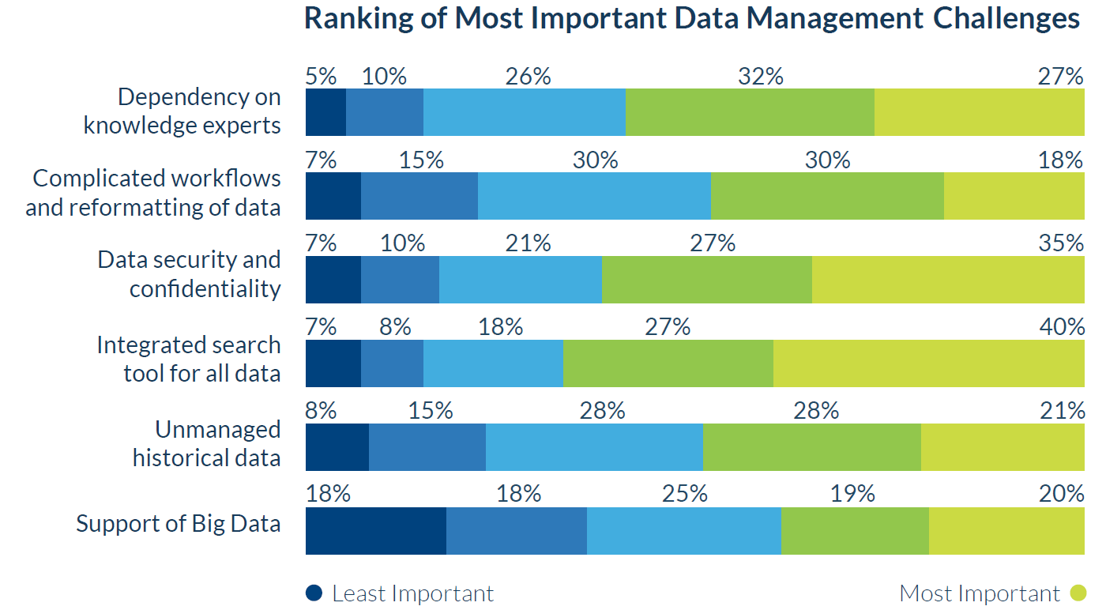

Here are some key observations:

**Search tools need improvement**

Asked to rank the comparative importance of data management challenges, respondents from all groups put the inability to find data through an integrated search tool at the top. Data security was a close second while dependency on knowledge experts also emerged as a pressing concern, especially for data administrators. By comparison, the biggest data management challenge in 2015 was the amount of unmanaged historical data.

**Geoscientists spend valuable time managing data**

Geoscientists spend 20-50% of their time managing data according to almost half of the respondents, time they could be devoting to other critical tasks such as exploration. In the 2015 survey, a quarter of the respondents did not know how much time their geoscientists spent on data management. But that number dropped to 11% in 2017, suggesting there is a growing awareness within organizations about the time and human resources required.

**Culture and complexity outweigh cost as barriers**

For the 2017 survey, Geosoft asked respondents what the main challenges are when selecting and implementing a data management solution. A lack of dedicated resources to complete due diligence, a poor culture for managing data and perceived cost are major, similarly ranked concerns. However, for the 47% of respondents who consider data management a critical issue, cost is less of a concern.

Most respondents would prefer to purchase an in-house (31%) or cloud-based (24%) solution while 24% - more among government and energy organizations – are inclined to develop and in-house proprietary solution. Only 12% would like to maintain the status quo, allowing end users to manage their own data, and 8% would outsource their data management.

Once a data management solution is in place, the complexity of integrating data silos becomes the main concern followed closely by the time and resources required to maintain and fully populate the solution. Just 17% of the respondents rank cost as the most important consideration.

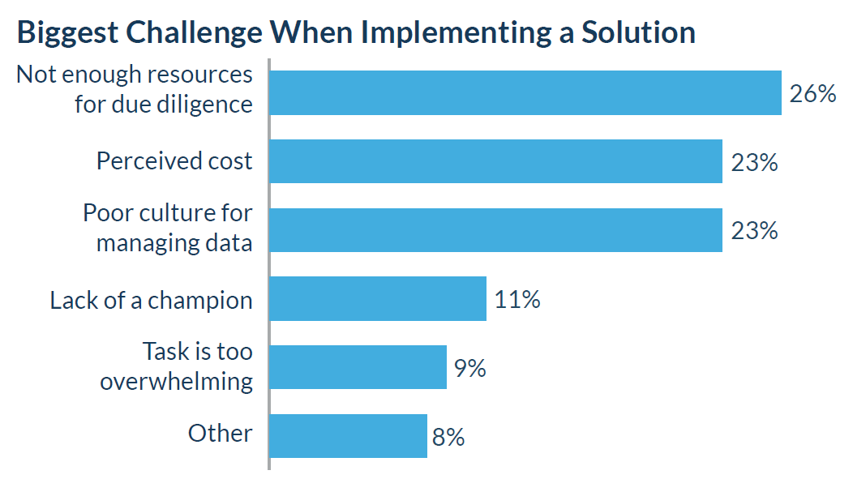

**Security concerns limit use of cloud**

Even though more than half of respondents feel they are “very “ or “somewhat” ready to leverage the cloud for geoscience data management and access – and many already are - a full 32% consider security the cloud’s biggest drawback. Cost, performance and reliability are also concerns, but keeping data secure is by far the most common challenge. The exceptions are those working in the education sector or who identified as data administrators. They are more worried about cost.

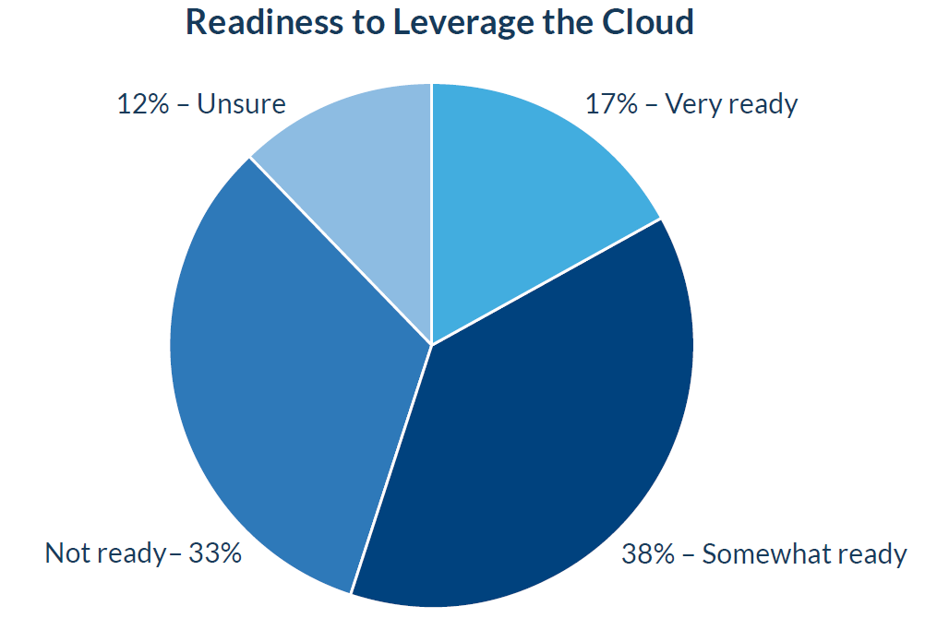

**Getting full value tops the wish list**

About 40% of the respondents feel that the most significant outcome from resolving data management issues would be to get full value from their data. Next on the wish list are preserving data, having one point of access for all data, increasing discovery rates, and improving accessibility for reporting and attracting investment. Geosoft broadened the outcomes question in 2017 to include more options based on feedback from previous surveys.

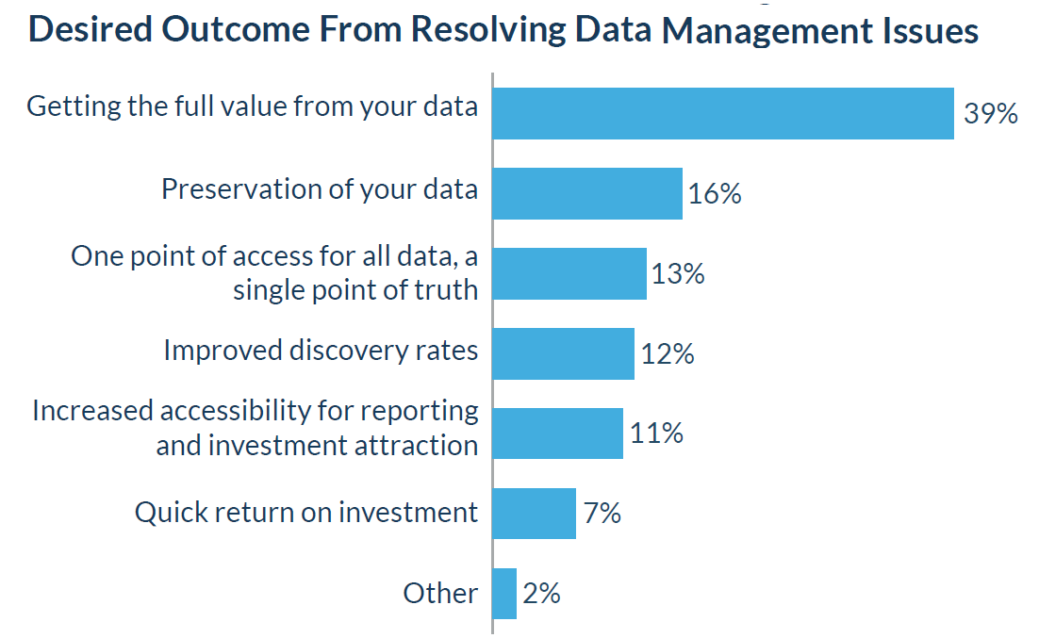

**Conclusions**

Accessibility and security concerns are holding organizations back from getting the full value of their data. To save time and increase efficiency, they need to a single search tool. To properly leverage the computing power of the cloud, they need better security.

Most respondents would prefer to purchase a commercial solution to outsourcing or developing a solution in-house. While cost remains a significant barrier, limited resources for due diligence or a poor culture for managing data are also preventing organizations from selecting and implementing geoscience data management solutions.

More information is available in the survey report which can be downloaded from the [Geosoft website](http://www.geosoft.com/geoscience-data-management-survey-2017).